DECISIONS DELEGATED TO OFFICERS

Decision title: | City Centre land – entering into a contract to appoint a consultant to provide commercial agency services.
Decision date: | 24 February 2022
Source of delegation: | This decision was delegated to officers under Part 4.4 of the Council’s Constitution: all executive functions except those in Parts 4.5, 4.6 and 4.7 are delegated to officers in the senior management structure.
What decision was made? | The decision has been made to appoint JLL to undertake commercial agency services.
Purpose: | The consultant is to undertake commercial property consultancy and agency advice in relation to the site. A property consultant is required to ensure that the proposition is market sharp, attracts occupier, investor and developer interest and meets our objectives.  JLL has been appointed to carry out the work.
Reasons: | The decision was made to enable work on commercial agency services in order to be a good landlord and seek to sustain income from this site. The work is time critical so as to be able to progress good decision making on the site in advance of key lease expiry dates.
Decision made by: | Tom Bridgman, Executive Director (Development)
Other options considered: | The option of not procuring a consultant was rejected as it would not allow the Council to meet its objective of maximising income from the site.  Alternative routes to procuring a commercial agent were considered, but the use of Request for Quotes to known experienced contractors to procure a competent team to undertake the work was considered by the Head of Property and the project team as the most expedient way to secure the consultants required.
Documents considered: | Not applicable
Key or Not Key: | Not Key
Wards significantly affected: | None
Declared conflict of interest: | None
This form was completed by:  Name & title:  Date: | Carri Unwin, Regeneration Manager  24 February 2022

Approval checklist

Approver | Name and job title | Date
Decision maker | Tom Bridgman, Executive Director (Development)  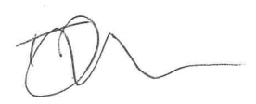 | 24.02.22

Consultee checklist

Head of Corporate Property | Jane Winfield, Head of Corporate Property  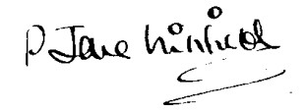 | 10.02.22
Cabinet Member | Cllr Ed Turner, Deputy Leader (Statutory) – Finance and Asset Management | 24.01.22
Ward Member | Cllr Alex Hollingsworth, Carfax & Jericho | 24.01.22

